Mapping Tabular Data – Display XY points from csv
Materials needed: AussiePublicToilets.csv.
[1] Open and examine the data:
Open ArcMap and use the Add Data 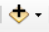 button to add the table AussiePublicToilets.csv to the map. Right-click > Open to open the table. Take a moment to inspect the field (column) names and the values beneath them. At the bottom of the table, note that there are 18,865 records, each representing one public restroom, though none show up on the map yet.
Notice that there are columns for Latitude and Longitude, and that the values in these columns look a lot like decimal degrees. (Metadata confirms that the data were recorded using GCS_WGS84.)
[2] Set the dataframe coordinate system to WGS84:
Right-click on the word Layers, then Properties, then choose the tab for Coordinate System. Search for WGS 1984, and choose the plain version that lives under Geographic Coordinate Systems > World. Notice that the units in the lower right-hand corner are now decimal degrees.
[3] Plot the coordinates as points:
Right-click on table in the Table of Contents. Choose Display XY Data .. A dialog box opens, asking which fields to use as X and Y coordinates. Choose Longitude for X, Latitude for Y.
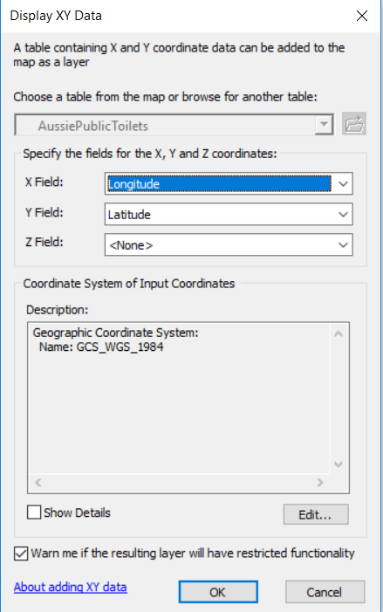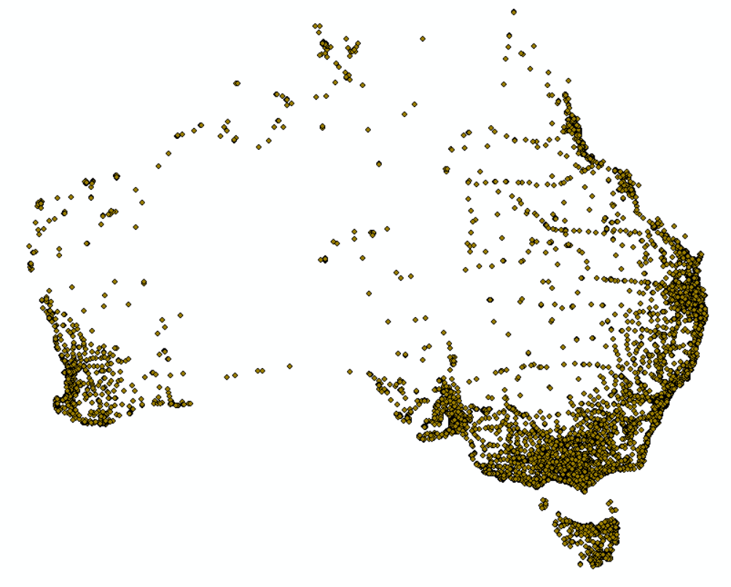
[4] Remember that this layer of points is temporary. To make it permanent, right-click on AussiePublicToilets Events. Choose Data > Export. Name the new file AussiePublicToilets.shp and save it somewhere you will be able to find it again. Add that saved file to the map and remove both the events layer and the .csv (right-click > Remove).

Mapping Tabular Data – Select a Subset by Attributes
[1] Click the Select icon. Practice click-selecting on the Australian points. Shift-click will allow you to select several points. You can also hold down the left mouse button and drag a box to select a large area. When you are done, Clear Selected Features. At any time, you can return to a regular cursor by clicking on the black arrow.

[2] From the Selection menu at the top, choose Select by Attribute. A calculator opens, where you will concoct a logical expression. Make sure the Layer says AussiePublicToilets and the Method is “Create a new selection.” We will select only the bathrooms that are free of charge.
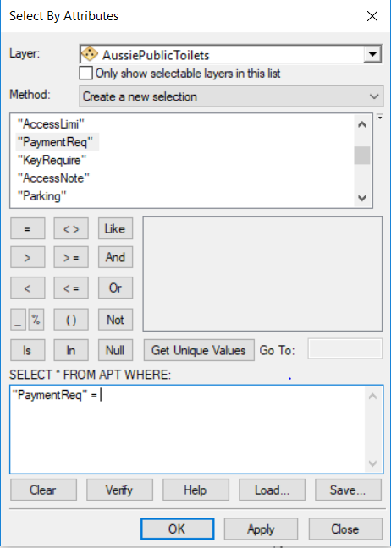
Double-click the field name
“PaymentReq.” It will appear in the expression box. Then click the = and that will appear as well.

To see what PaymentReq could possibly be equal to, click
[Get Unique Values]. Choose “False.” Your expression
should now read: “PaymentReq = ‘False’

Click OK.

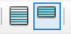
[3] Inspect the map and the Attribute Table. 162 public toilets were excluded from the selection. Play with the Switch Selection button at the top of the Attribute Table, and Show Selected Records at the bottom.

[4] Narrow the selection by launching Select By Attributes again. This time, change Method to “Select from Current Selection” and build the expression “KeyRequire” = ‘False’ and inspect the updated selection. These are all of the public bathrooms on the entire continent that are open access, no key or payment required.
[5] Data selections are temporary. To make a new layer that is only the selected portion of the old, right-click on AussiePublicToilets in the Table of Contents and choose Data > Export again. This time, make sure the top box says “Selcted Features.” Give it a name and storage destination and click OK.
Close ArcMap for now.
Mapping Tabular Data – Joining Census Tables
Materials needed: American Factfinder website, Middlesex_Tracts.shp, and Travel_90min.csv
[1] Open a browser and navigate to http://factfinder2.census.gov. Choose [ Advanced Search] and [ SHOW ME ALL].
[2] In the left-hand margin, click on [ Geographies ].

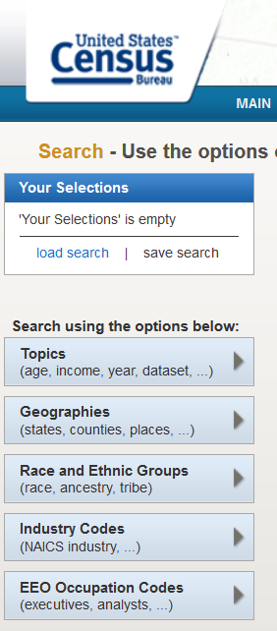
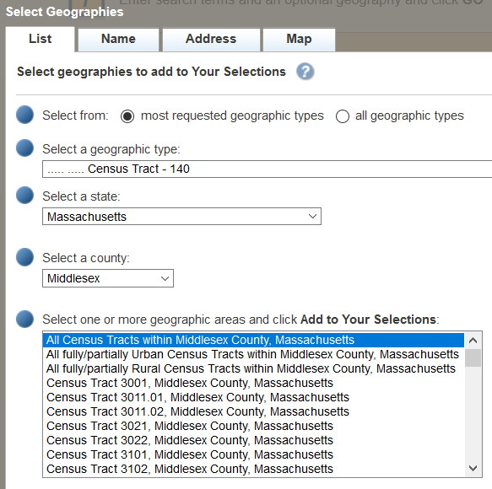
In the dialog box that opens, choose from the pulldown-menus.
For geographic type, choose Census Tracts.
Choose Massachusetts and Middlesex County.
Then choose All Census Tracts for Middlesex County, Massachusetts.
Finish this step by clicking
[ ADD TO YOUR SELECTIONS ].
The dialog box will close.

[3] In the topic search box, enter B08303. This should discover the census topic TRAVEL TIME TO WORK. Check the box next to the most recent version, and then choose Download.
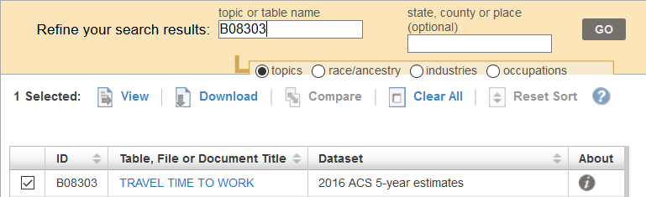
Unzip your downloaded folder, navigate to it, and open the file ACS_16_5YR_B08303 _with_ann.csv with Excel or Notepad to inspect it.

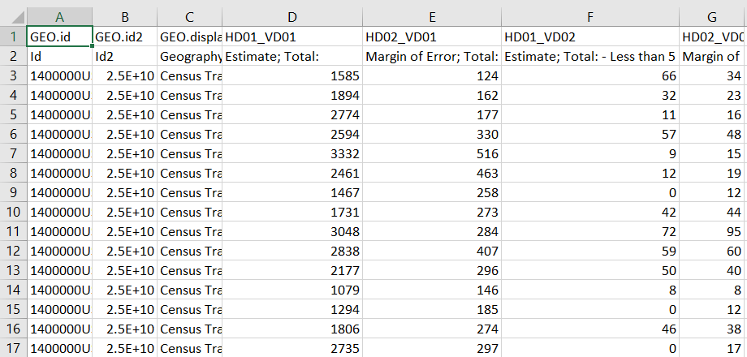
[4] Notice a few things about this spreadsheet. The first row contains indecipherable census codes for each variable. The second row contains more readable descriptions, but those descriptions have punctuation that may confuse ArcMap. Also, ArcMap is not prepared to handle data with two header rows. Furthermore, there are many more columns than we may want to use.
Let’s suppose we were only interested in super-commuters, people who commute more than 90 minutes to work, the second-to-last column. We could remove unwanted columns and rename the headers like this:
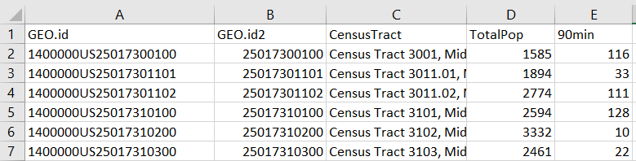
This has already been done for you* and is saved in your lab materials as Travel_90min.csv. Likewise, the census tracts of Massachusetts have been selected to the subset for Middlesex county and saved as Middlesex_Tracts.shp.
The Geo.id fields have not been changed, because we are hoping to find a join key field that matches exactly some field in the tracts shapefile In ArcMap, open a new map or dataframe, and please add both Middlesex_Tracts.shp and Travel_90min.csv. Inspecting both tables reveals that GEO.id2 should be a good match for GEOID2.
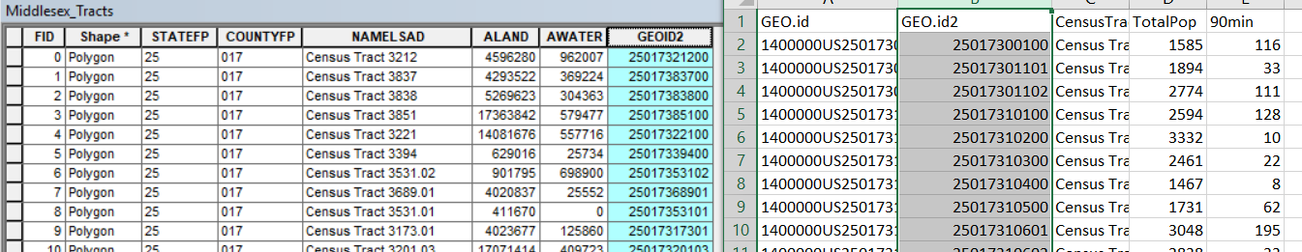
[5] To begin the join, start with the shapefile layer in the Table of Contents. Right-click and choose Joins and Relates > Join … The following dialog box appears:
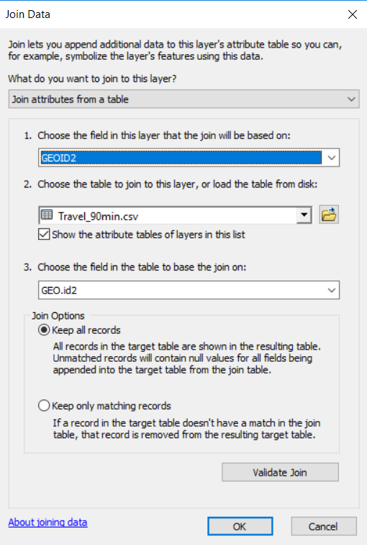
This is where you tell ArcMap what the right-hand table will be (Travel_90min) and what the matching fields will be – GEOID2 and GEO.id2.
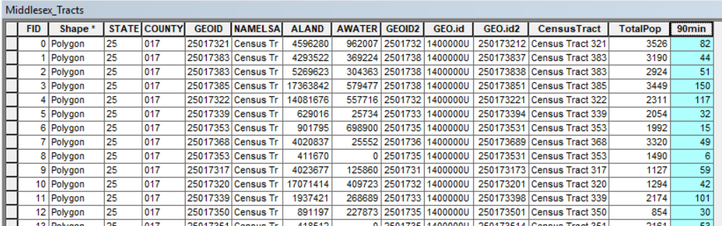
Click OK and then inspect the Attribute Table for Middlesex_Tracts. Five newly added columns represent the information from the census table.

To keep those columns permanently, you must export a new copy of Middlesex_Tracts.shp using Right-click > Data > Export. For use in the following exercises, please name your export Middlesex_joined.shp. We can now display the census tracts symbolized according to number of residents traveling more than 90 minutes to work:

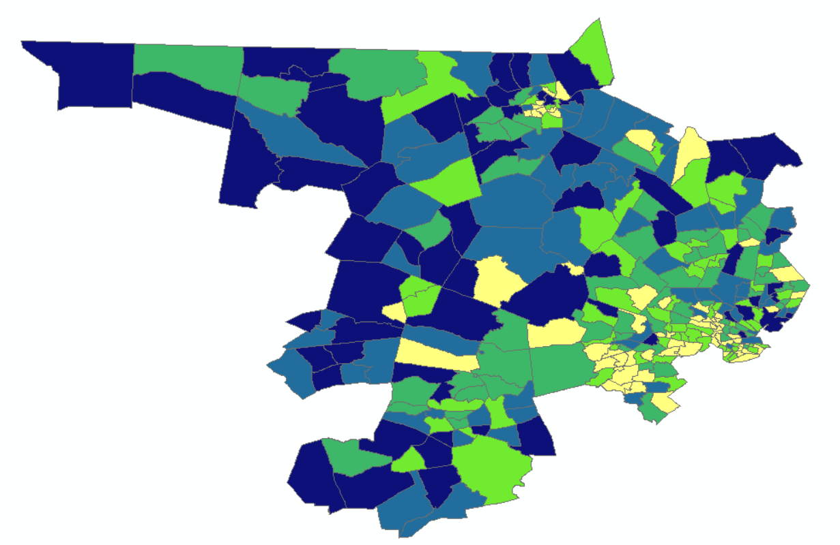

Extra: Field Calculation
Materials needed: Middlesex_joined.shp, your exported shapefile from the previous section
How could we change this map to display the fraction of commuters making this long journey? Two ways: visually only or using an actual calculation in the Attribute Table.
[1] Under Properties > Symbology > Quantities, we can Normalize the values shown by the field TotalPop.
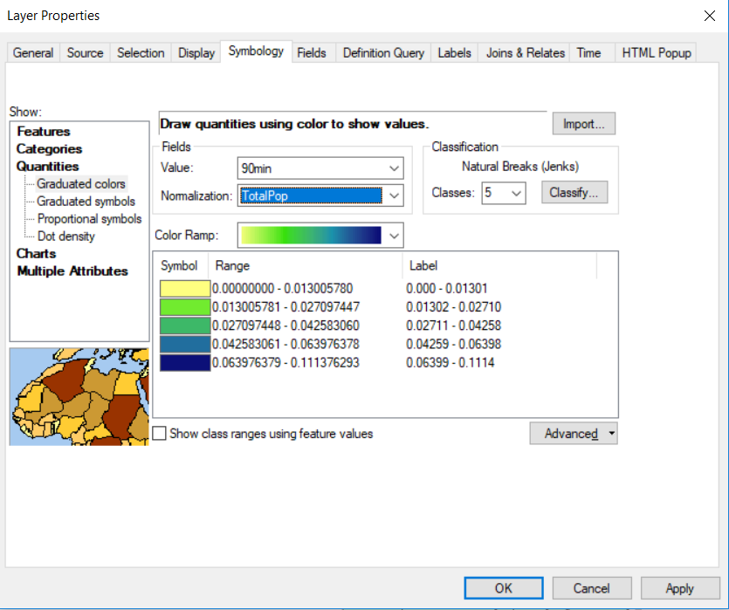
Think about how this meaning is different from <PERCENT OF TOTAL>. Which total?
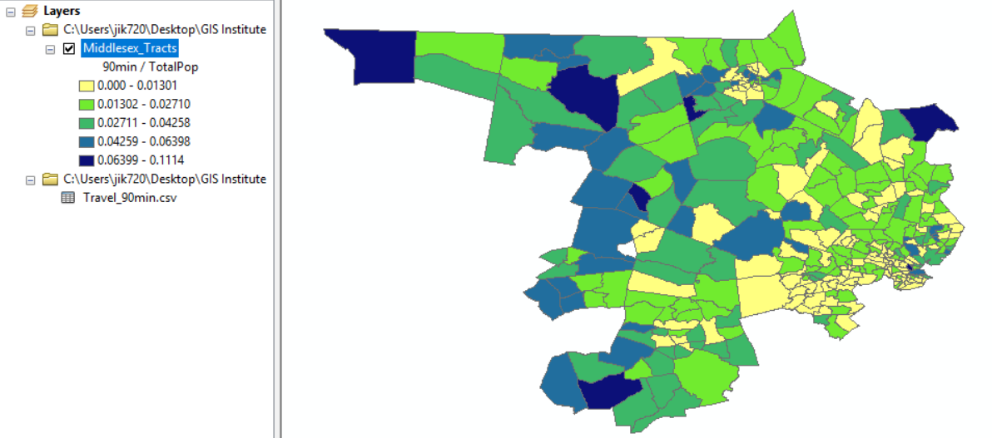
[2] To make a real, permanent calculation of the fraction of super-commuters, open the Attribute Table. Pull down the Table Options menu and choose Add Field.
The following dialog box appears. Choose the options shown:
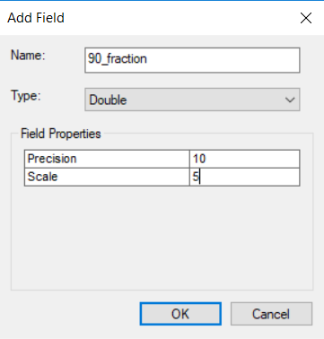

The field type “Double” means numeric with the possibility of decimal values, which is necessary when computing a fraction. Precision and scale describe how many place values will be available in total and after the decimal point. Field names can have no spaces. They must be fairly short and they cannot be re-used.
There is now a new, empty field in the Attribute Table. Right click at the top of it and choose Field Calculator.
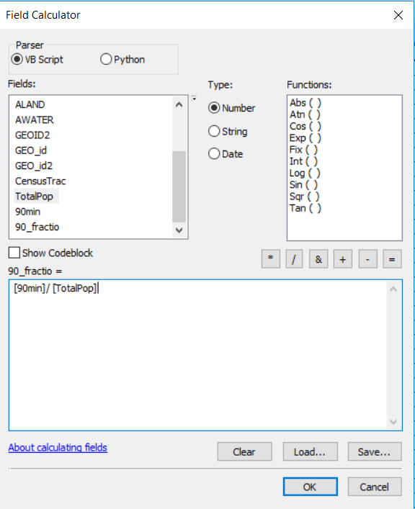

This new calculator appears rather similar to the
Select by Attribute calculator.

Create a formula to calculate values for the new
field: [90min]/ [TotalPop]

If we were concerned about a denominator being zero, we could use [90min]/ ([TotalPop] + 0.01). Alternatively, we could Select those tracts with non-zero populations. If we preferred percentage to proportion, we could use100*[90min]/ [TotalPop].

Press OK to execute the calculation. The field is filled with new values, and Symbology can now make use of them. Interestingly, the quantile breaks are different for this computed field than they were for the normalized symbology. Why do you think that is?

Extra: Spatial Join
Materials needed: AussiePublicToilets.shp, Municipalities.shp

[1] Open and examine the data:
Open ArcMap and use the Add Data button to add both shapefiles to the map.
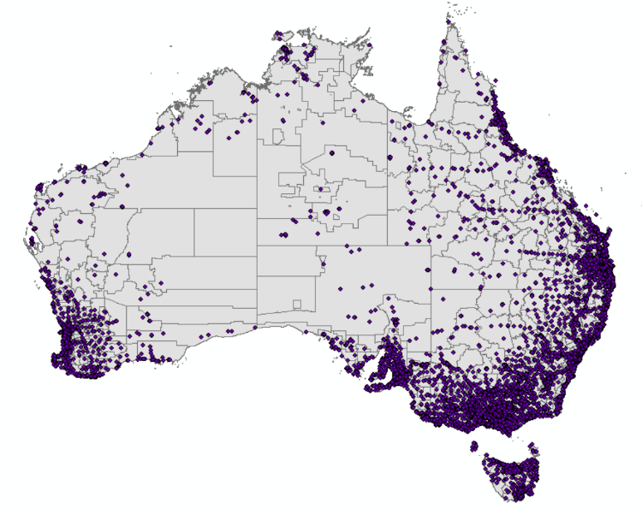
Spatial Join is a technique that associates one layer with the features of another based on their location in space.

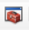
[2] First, let’s join the municipalities to the toilets, so that each toilet will have information about which municipality it’s in. Click the ArcToolbox icon to open the Toolbox.
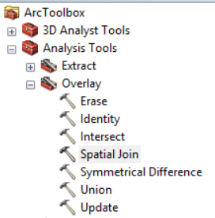
Then navigate to Analysis > Overlay > Spatial Join.

Double-click to run the
tool.

The first time we join, the Target Layer will be the toilets and the Join Layer will
be the municipalities. Join one-to-one. At the bottom of the dialog, you will see a choice for Match Option, set to INTERSECT. For now, leave that choice, but inspect the alternatives in the drop-down menu. Run the tool and inspect the output. The output is a set of points, and new columns have been added to the right of the attribute table containing all of the information from the Municipalities shapefile.

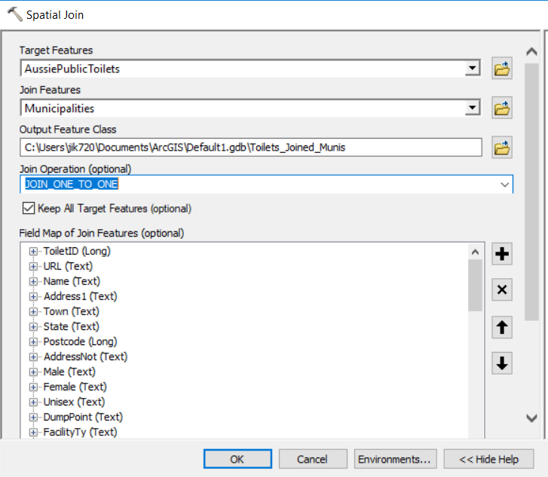

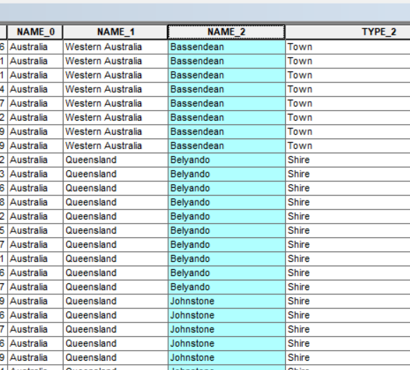
[2] Now let’s do the opposite: tell each municipality about the toilets it contains. We could spatially join one-to-many, but that would make many copies of each municipality, one for each toilet it contains.

Instead, let’s get a summary for each municipality, using one-to-one. Open the Spatial Join tool, make the municipalities the Target Layer and the toilets the Join Layer.
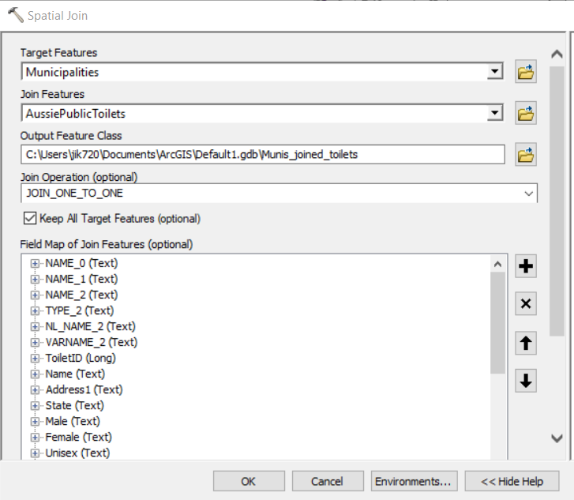
Now, as it says in the help window, we need to set a Merge Rule.

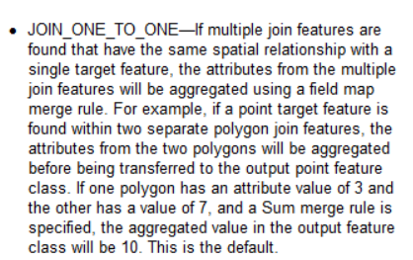

Decide which field you would like summary information about, and right-click it in the list.
Let’s get the count of unique toilet ID numbers per municipality.
Right-click on ToiletID, select Merge Rule, and then Count.
Leave the Match Option as INTERSECT and run the tool.
Inspect the output. This time, the output is a set of polygons, and a new field has been added which gives the count of toilets per municipality.
We can change the symbology to display that quantity.

